Topics:

1. Remind of process 2
2. PROCEDURE 3
Run transaction MRN9 3

Remind of process

Local Valuation of inventory will be run once a year, using a specific Costing variant, under budget version 002 of Cost center planning (new activity prices).
The field TAX 1 will be updated in the Material Master Data (last step of the costing run)

FI posting for local valuation differences will be done manually

Steps :
- Run Balance Sheet Value analysis

Standard Program in MM Inventory Valuation, used to get different between the Tax 1 price stored in the preceding step, and the current valuation price of the material

- Post the Difference

The list will present valuation differences per material.
FI posting for revaluation (either local of group) will be done manually.

PROCEDURE

Run transaction MRN9
Objective : Obtain the difference between Tax Price 1 and Standard Price per G/L account.

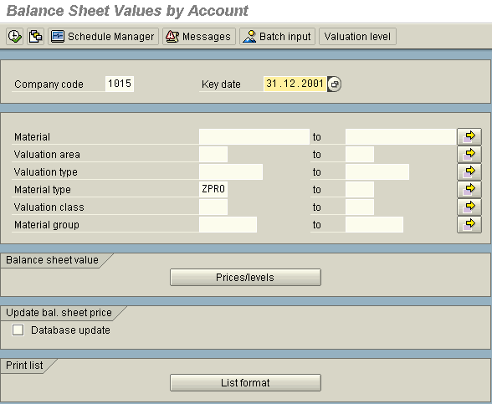

- Date of year end closing
Make the operation
for material type
ZPRO

This field enables you to choose which prices have to be compared.

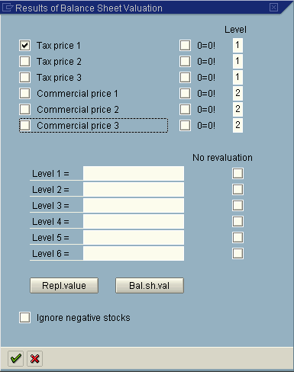

Execute

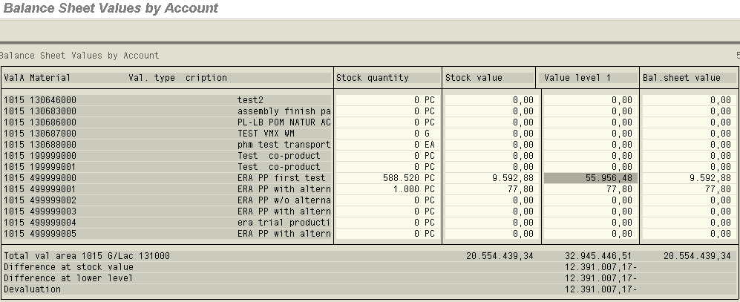

The system provides you, per part & per G/L account, the difference between Standard Price and Tax Price 1 (for parts in Stock at the date chosen).

